- Bluebook Page80 May 2019 variant three examination:
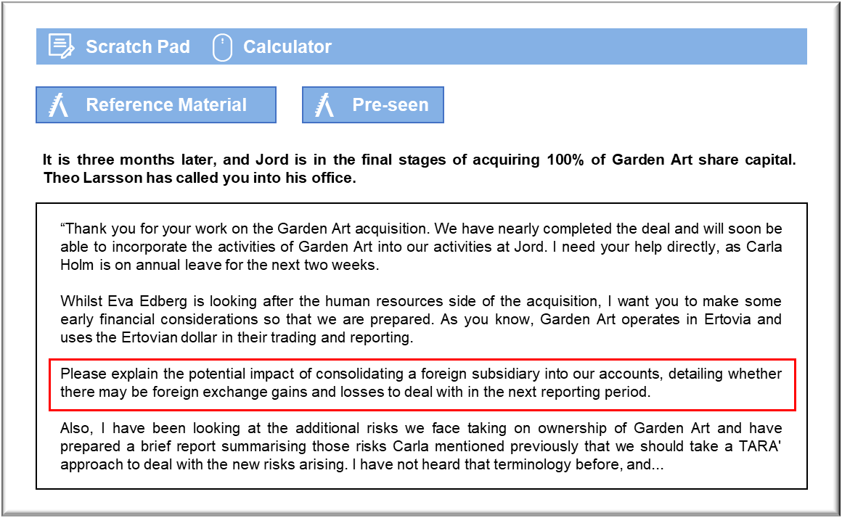

MANAGEMENT CASE STUDY MAY 2019 EXAM ANSWERS

Variant3 Task2
These answers have been provided by CIMA for information purposes only. The answers created are indicative of a response that could be given by a good candidate. They are not to be considered exhaustive, and other appropriate relevant responses would receive credit.

CIMA will not accept challenges to these answers on the basis of academic judgement.

Requirement - 1
With regards to the acquisition
In the accounts, the assets acquired will be brought into the statement of financial
position using the exchange rate applicable at the date of the transaction. An amount
of goodwill will probably be created, which is the difference between the amount paid
and the value of net assets acquired. There will be no foreign exchange gains or losses
to deal with at that stage.
With regards to ongoing trading
At each subsequent reporting period, Jord will translate the numbers for the subsidiary
into Corvolan dollars, which will be the presentation currency for Jord. The translated
numbers will then be consolidated in the group accounts.
The translation may create exchange rate differences that need to be dealt with in Jord
accounts.
In terms of the statement of financial position, Garden Art balances will need to be
translated at the reporting date. If the exchange rate has changed since the previous
year end (and, going forward, from the last reporting date) the translated value of
assets and liabilities will have changed giving rise to exchange gains or losses on
translation which will be recognised within other comprehensive income, held in a
separate reserve held within equity in the statement of financial position.
The Garden Art income statement will also need to be translated to Corvolan dollars at
the reporting date but based on the average rate of exchange during the financial
period.
The overall exchange difference (arising from retranslation of the prior year assets and
liabilities, and from the difference between the comprehensive income at average and
closing rate) will be recognised within other comprehensive income.
A further exchange difference then arises upon consolidation for goodwill, which will
also be recognised at the closing rate, and is retranslated from opening to closing rate.
However, we will need to ensure that any impairment is taken care of before
translating the balance.
In our case, Jord is acquiring 100% of the subsidiary, so we won’t have any non?controlling interests (NCI) to worry about. If there were any NCI’s, then the exchange
differences would have been split between Jord and the NCI’s based on a pro rata
basis.

TARA
Requirement 2 – What is TARA and how can we use it?
TARA is a framework for classifying risks according to both their likelihood and
impact. It can be argued that the combination of those two factors gives some insight
into how best to manage any given risk.
In its simplest form TARA classifies both likelihood and impart on a two-point scale to
give high and low for each. That can then be presented on a 2x2 matrix. Each cell then
May 2019 4 CIMA Gateway Case Study Exam
corresponds to one of four approaches that can be taken to managing risks. These are
identified by their initials:
Transfer – usually associated with high impact, low likelihood
Avoid – usually associated with high impact, high likelihood
Reduce - usually associated with low impact, high likelihood
Accept – usually associated with low impact, low probability
For example, the risk of legal problems is hopefully low impact, but the nature of our
business involves contracts and so there could be a high probability. That risk might be
reduced by hiring a local lawyer to advice.
If we assume that exchange rates are unlikely to be volatile then exchange differences
are potentially high impact, but low probability. They could be transferred by hedging
against currency movements on any receivables or payables in Etrovian dollars.
Cultural differences are unlikely to be significant enough to create problems because
the two aspects of the business will operate independently, so they are low likelihood
and low impact. That suggests they can be accepted.
The problems with trading performance are, potentially, high likelihood and high
impact because of the current position. That risk would be best avoided by developing
a new business model.
The risks associated with there being differences between the operations of Jord and
Garden Art are potentially high impact and high likelihood. A mechanical application
of TARA would suggest that they should be avoided, but the only way to do that would
be to abandon the investment. Given that the decision to invest has been made, the
most appropriate response would be to reduce the risk by, say, hiring a manager with
the necessary expertise to supervise Garden Art’s operations on Jord’s behalf. The
same could be said about customers not wanting to use Garden Art’s service. It is
probably high risk and high impact, but the risk might be reduced by promoting the
service.
The financial problems associated with gearing are also high impact and high
likelihood, but they might be accepted on the basis that Garden Art will become part of
the Jord Group, and the group could support the company through any difficult
periods.

